 Project Report Template

1. **INTRODUCTION** 
   1. Overview

OPTIMIZING FLIGHT BOOKING DECISIONS THROUGH MACHINE LEARNING PRICE PREDICTIONS

* 1. Purpose

Predict the price flight ticket.

**2 Problem Definition & Design Thinking**

2.1 Empathy Map

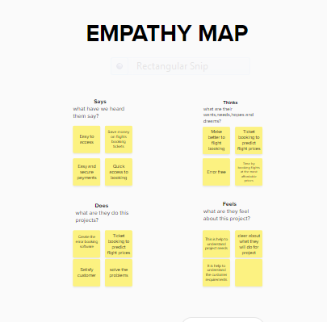

2.2 Ideation & Brainstorming Map

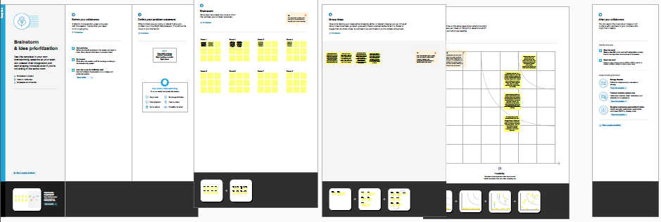

1. **RESULT**

* 1. Data Model:

|  |  |  |  |  |
| --- | --- | --- | --- | --- |
| **Object name** | **Fields in the Object** | | | |
| obj1 |  | | | |
|  | Field label | Data type |  |
| Airline | int |
| Price | int |
|  |  |
| obj2 |  |  |  | |
| Field label | Data type |  |
| Destinesion | string |
| Dup_time | int |
|  | |

* 1. **Activity & Screenshot**

Attach the screenshots of your project activity along with the description.

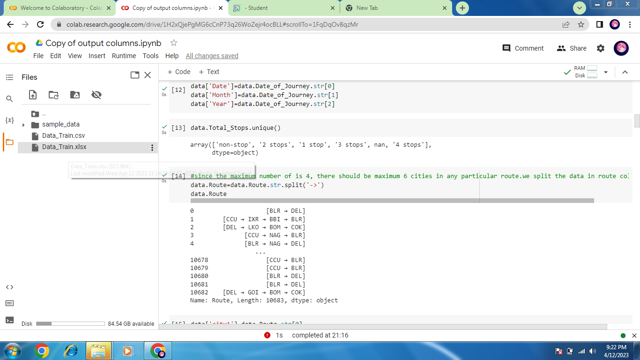

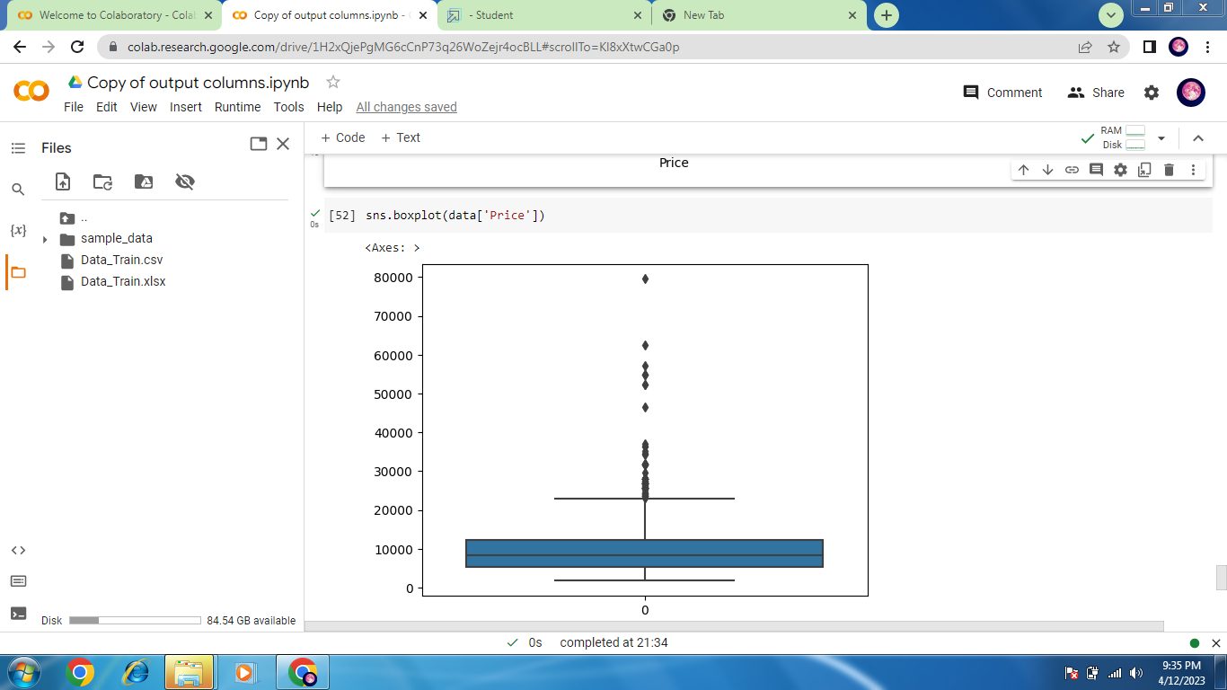

1. **Trailhead Profile Public URL**

**Team Lead:** **https://trailblazer.me/id/gokuk14**

**Team Member 1 - https://trailblazer.me/id/sdurai49**

**Team Member 2 -**

**Team Member 3 –**

 Project Report Template

1. **ADVANTAGES & DISADVANTAGE**

List of advantages and disadvantages of the proposed solution

Advantage:

Dataset help to make prepare data analysis

Disadvantage:

Model building de

1. **APPLICATIONS**

Google colab

1. **CONCLUSION**

We gave best in short time.

1. **FUTURE SCOPE**

Enhancements that can be made in the future.